Sustainability principles adopted by OUR company  Designing which are energy efficient  Designing of houses which have low impact on the environment and resources.  Designing of houses through methods which reduce the amount of waste that is released to the environment.  The designers of various buildings should also consider the use of methods which also promote a healthy environment. |  | Designing Houses through methods which promote environmental sustainability. |  | About us  We provide the best building solutions and promoting methods which protect the environment.  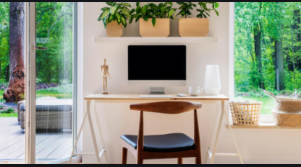
Street Address
City, St Zip Code
Phone Number
Website: www.buidingsolutions.com
Email:Buildingsolns@gmail .com
Ways of putting our principles into practice  Use of renewable sources of energy such as solar energy which has less impact on the environment.  Use of recyclable materials to avoid releasing weaste to the environmet which can contribute to pollution.  We promote the use of locally available materials in building to avoid the exploitation of the natural resources and cutting of trees.  The houses are built on the minimum possible space to minimize the use nof unnecessary space which requires the destruction of the environment. |  | A List of our services  We design and plan buildings for our clients.  We offer advice on the best building sites for our clients.  We also provide recyclable building materials.  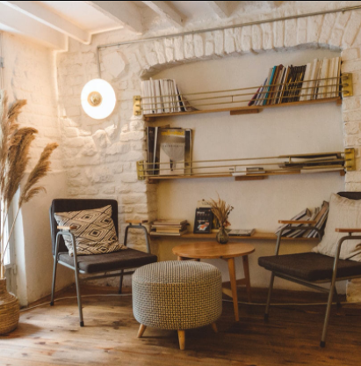 |  | why you should choose us  - Our designs and construction of buildings are meant to promote better living conditions and a healthy environment.  - We promote efficient use of the available space for maximum interaction of the people with the available space ecologically.  - We use materials which are both locally available with protecting the immediate environmental resources from overexploitation.

